FMCW Snow Level Radar

Hardware:

Measurement Computing USB-2523 Data Acquisition board

$1,045

USB, 16bit resolution, 1MS/s sample rate, 24 digital I/O

Win10 64 bit – Visual Studio – C++/C# library

<https://www.mccdaq.com/usb-data-acquisition/USB-2500-Series.aspx>

DaqBoard3005USB

SpinCore PulseBlaser PB24-100-4k-PCI Timing Generator

$1,525

PCI, 24 channels, 100MHz clock, 4K memory words, 50 shortest pulse, 10ns pulse resolution

Win 2000, C, SpinAPI.Net C#, Visual Studio 2008

<http://www.spincore.com/products/PulseBlaster/>

SpinCore Technologies, Inc: PulseBlaster-12(SP17)

EVAL-AD9959 DDS

$412

USB, 4-Channel, 500 MSPS, 10-Bit DACs

Windows 64bit driver

Currently having issues controlling it. May need an Arduino to control it.

<https://www.analog.com/media/en/technical-documentation/evaluation-documentation/57418637811849AD9959_pcb_0.pdf>

Mini-Circuits USB/Ethernet Smart Power Sensor

$

USB, Ethernet, ???

OS

<https://www.minicircuits.com/WebStore/RF-Smart-Power-Sensors.html>

<https://www.minicircuits.com/softwaredownload/PM_Programming_Manual.pdf>

RedPitaya StemLab Data Acquisition and Signal Generator

Possible replacement for ISA Analog Hardware

<https://www.redpitaya.com/>

Libraries

LibUSBK:

For AD9959 DDS

Version in use is LibUsbDotNet.dll 2.2.5.61

Latest version (3.0.7.0) is from 2014 and does not support higher than Win2000

<https://sourceforge.net/projects/libusbk/>

<http://libusbk.sourceforge.net/UsbK3/index.html>

MathNet.Iridium

Replaced with Math.Net Numerics - current version (4.15.0) is from 2020

MathNet.iridium version in use is 2008.8.16.470

<https://iridium.mathdotnet.com/>

<https://numerics.mathdotnet.com/>

Numerical Methods Library

Don't now where Dave got this dll

DAQCOM:

For DaqBoard3005USB board

32 and 64 bit dlls

Differences with Lapxm:

Control Panel:

* Calculates some parameters similar to the Lapxm Easy Editor

* Parameters stay the same once the radar is set up and running

Data Acquisition:

* Some differences in how the time series is handled before it can be passed into Lapxm’s normal chain of algorithms.

Snow Level Algorithm

* Discrimination on width

* Peak picking is limited to 0-6m/s instead of full Nyquist

* Signal to noise ???

S-Band FM-CW Snow Level Radar

Snow Level Radar

S-Band Radar

The **S band** is a designation by the [Institute of Electrical and Electronics Engineers](https://en.wikipedia.org/wiki/Institute_of_Electrical_and_Electronics_Engineers) (IEEE) for a part of the [microwave](https://en.wikipedia.org/wiki/Microwave) [band](https://en.wikipedia.org/wiki/Radio_band) of the [electromagnetic spectrum](https://en.wikipedia.org/wiki/Electromagnetic_spectrum) covering [frequencies](https://en.wikipedia.org/wiki/Frequency) from 2 to 4 [gigahertz](https://en.wikipedia.org/wiki/Gigahertz) (GHz).

FM-CW

*Frequency-modulated continuous-wave radar* (FM-CW) – also called continuous-wave frequency-modulated (CWFM) radar[[5]](https://en.wikipedia.org/wiki/Continuous-wave_radar) – is a short-range measuring radar set capable of determining distance

Brightband Height

220 mW

**Installation Notes:**

**Server Installation**

To Install the PopNServer Service:

- Run PopN.exe 'as administrator' - PopN will install the service for you

OR

- Run CMD as administrator

- CD to the directory containing PopNService.exe

- Type PopNService.exe /i

- /u = uninstall service, /stop = stop service, no argument = start service

To uninstall the service, run CMD as admin and type sc delete PopNService

**MC USB2523 DAQ**

- run mccdaq.exe (2.6)

- allow the device manager to detect the board – it will be under DAS Component -> USB 2523

- if needed update driver and select USB-2523 (not DaqBoard3005)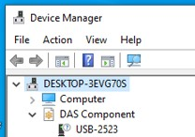

- Could run InstaCal and run a performance test and a DIO test

- Could run DAQami and see test sin and square waves

Spin Core PulseBlaster-12(SP17)

- run SpincCore_API_20150129.exe (32 bit) (or _x86_64 for 64 bit)

- latest version is SpinCore_API_20171214_Universal

POPN.exe

- Must run as an administrator to display graphs

**Systems:**

* 11 systems in the field

* All running roughly the same way with the same parameters with one receiver

* 3 new systems are being built.

- 1 will be Dual Polar for Crested Butte - uses 2 receivers

* Main data product is Spectra and Moments.

- Crested Butte will also record Time Series (I&Q)

* Raw Time Series is available but only used for testing (not available on Lapxm)

* Spaced Antenna features never used in field (DDS#3 & #4, Cross Correlation, Wavelets)

**POPN4 Issues:**

- Paul deployed only on one system and remembers the issue was that the first gate was at sea level instead of actual altitude

- Pulsed mode never completed - parameters in GUI not useable

**Parameters:**

**Systems Tab:**

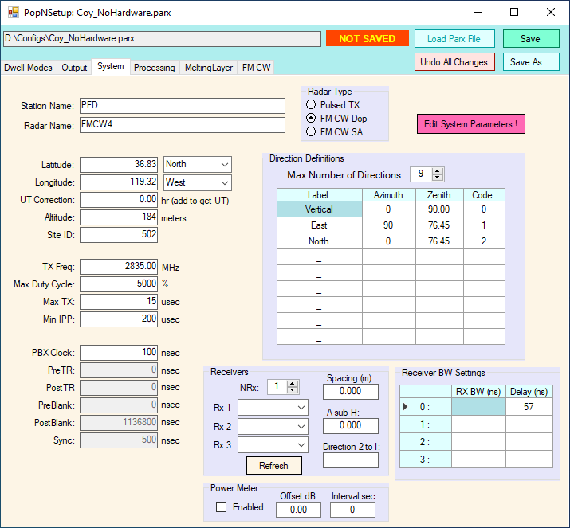

Site file info

Station Name

Radar Name

Latitude

Longitude

UTC Correction

Altitude

Site ID

Hardware File Info

TX Frequency

Receiver IDs (read from the DAQ board)

- Spacing, A sub-H, Direction 2 to 1 (only used on Spaced Antenna system)

Power Meter Enable (creates a file containing power reading)

Power Meter Offset dB

Power Meter Interval sec

Not used by SLR?

Max Duty Cycle

Max TX

Min IPP

Not used by SLR (for pulsed radar)

Direction Definitions - SLR only points vertically.

Receiver BW (bandwidth) Settings

**FM CW Tab**

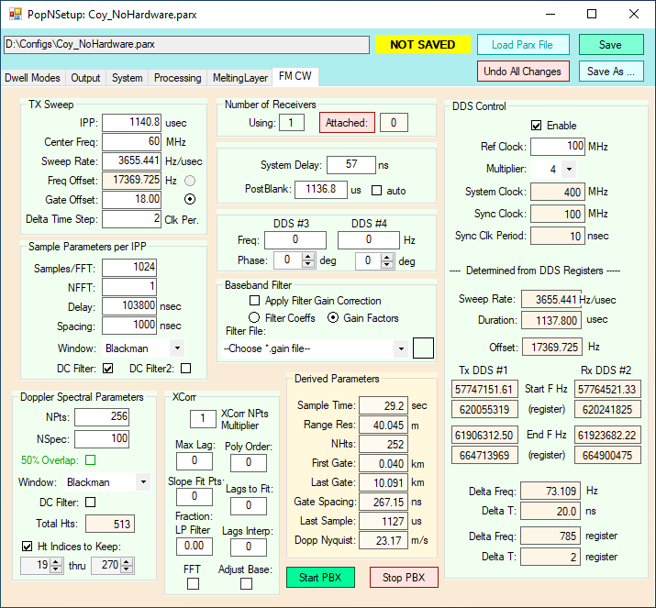

Config File Parameters

Dwell Mode

IPP = Inter-Sweep Period (ISP) - Time to make one sweep through the frequency - TR to TR

Center Frequency = Center of the frequency sweep

Sweep Rate = slope - Change in frequency per microsecond

Frequency Offset = Hz added to the received signal

- make differences between TX and RX inside pass band filter

- otherwise, the difference at gate 0 would be 0 and thus near DC

Gate Offset - Used to set the Frequency Offset.

- easy way to let the software calculate the offset

- the offset should land on a gate

Delta Time Step = Change in frequency generated by DDS per 1 100 MHz clock cycle

Sample/FFT = number of samples per Inter-Sweep Period (ISP)

Npts = # of sweeps in FFT

NSpec = Number of Npts averaged together

Window = usually use Blackman window to reduce leakage into adjacent ranges or velocities

DC Filter = removes DC – similar to Lapxm

Ht Indices to Keep = first gate is the zero gate but offset by the Gate Offset.

- The last gate is the usable height of the data (roughly 11km)

Hardware File:

System Delay = delay through hardware

Post Blank – time after TR

Broadband filter – file uploaded that shows the filter characteristics.

- FMCW does not have equal gain in every range. The filter file compensates

DDS Enable – enables the DDS

DDS Ref Clock – input clock to the DDS

DDS Multiplier – multiplies the input clock

- DDS can only generate specific frequencies. Need to get things to match up

Displayed information:

- Number of receivers

- Derived Parameters

Not Used

- XCorr – used for spaced antenna

- DDS#3 and DDS#4 – used for spaced antenna

**Processing Tab**

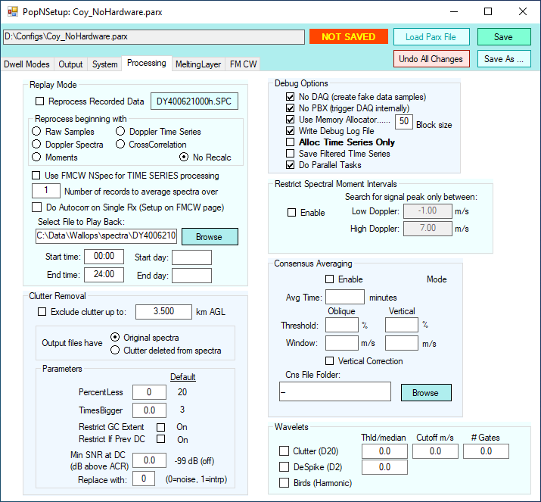

Replay mode is similar to Lapxm Replay.

Clutter Removal is similar to Lapxm.

The only debug option that is important is Memory Allocator.

- Due to memory issues on older PCs, Spectra is processed in blocks of gates

Restrict Spectral Moments Intervals - in Lapxm??

Consensus Averaging is not used - done in post processing.

Wavelets not used - for Spaced Antenna.

**Melting Layer Tab**

Basically, the same as the Lapxm Melting Layer Module

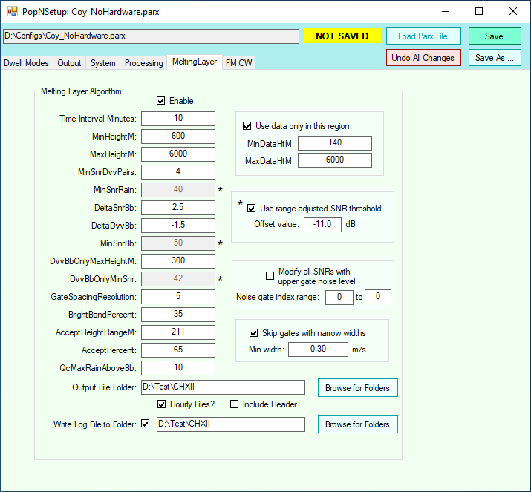

Differences between POPN and Lapxm

- POPN uses SNR instead of Reflectivity

-- Paul claims that Dan and Alan use Reflectivity which is SNR * R^2 * Offset

- POPN uses a spectral width discriminator

-- does Lapxm do this now?

**Output Tab**

Basically, the same as the Lapxm Pop Archiver Module

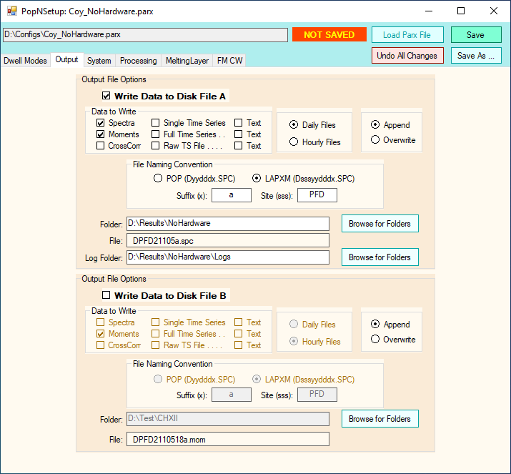

Has ability to write raw TS files (used for testing)

- Lapxm does not ?

**Dwell Modes Tab**

Only for Pulsed Radar and was not completed.

